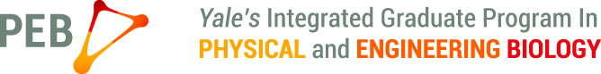

Application form for PEB travel fund

PEB will provide PEB students with up to $1,500 per year (June 1 – May 31) towards attending a conference.

To receive these funds, please have your PI send a brief e-mail to peb@yale.edu supporting your application, and fill out and e-mail this form to peb@yale.edu
* Examples provided are not real

- Name of the meeting / conference (example: American Physical Society March meeting):

- Date of the meeting / conference (example; March 2-6, 2015):

- Typically, who and how many attend these meetings (example: This is a meeting for any members of the American Physical Society, which includes almost all physicists in this country and about 9,000–12,000 attend every year.)?

- Are you presenting a poster or giving a talk? If so, please write down your poster or talk title.

- How much funding are you requesting and what for (accommodations, travel, registration, etc.; example: I would like to request $1,500 in total, $550 for airfare, $200 for registration, and $750 for accommodations)?

